Skill.me by Pipe9
Summary of Subscription Terms
Revision 3.1: Last Shared on: 1/13/21, Updated: 7/1/2021, Last Updated 1/31/2022, Last Updated 2/12/2022.
Thank you for your interest in Skill.me by Pipe9. This document provides a summary of the Subscriber terms incorporated into the agreement between Pipe9 and Subscriber as set and implied into Statement of Work (SOW)s.
Skill.me
Skill.me is an applied for registered trademark of Pipe9 Consulting LLC.
Skill.me is a Microsoft TEAMS based Skills App available from the Microsoft TEAMS App Store.
Skill.me is purchased based on a per user/per month subscription.
Skill.me Licenses:
- Subscriptions give users exclusive access to the Skill.me "In-the-Box" feature list.
- Subscription rates are based on the Skill.me “Licensing Model”.
- Subscriptions are purchased for a period of 12 months from the day of purchase.
- Subscriptions are purchased 12 months in advance with an applied 10% discount.
- Subscriptions are purchased to use a specified "Role based Skill Profile" set-up in the "Skill.me Creator App" and published for use in "Skill.me".
- A subscription is given to an individual user and is non-transferable to another user.
- A subscription is given to access a pre-defined "Skill Profile" and is non-transferable to another "Skill Profile".
- "Managers" and "Team Members” (IC's) using Skill.me are counted as two unique users.
- Subscriptions are automatically renewed unless the subscription is cancelled by the client within 30 days of the end of the subscription period.
- Subscriptions remain active for a period of 90 days after the end of a subscription period and will be deactivated after this period for non-payment.
- Deactivated subscriber data will be returned to a nominated "Officer" of the subscribing client. Data will be deleted 120 days after the end of a non-payment subscription period.
Skill.me Services:
- Skill.me Services are purchased based on a per user/per month subscription.
- Subscription rates are based on the Skill.me “Services Model”.
- A set of Services are attached to each Skill.me subscription/user License. These services are defined as "Essential" and "Elective" services.
- Services defined as "Essential" are required subscription-based services and must be purchased with each Skill.me subscription/user license.
- Services defined as "Elective" are recommended subscription based services and are purchased on a client discretionary basis.
- Services are purchased 12 months in advance with an applied 10% discount.
#/Details of Users:
- The # of Subscribing users is defined by the chosen “License Plan A-G”.
- Details of each subscriber (Read Skill.me Data Privacy) are provided to Pipe9 in advance of the subscription “Start Date” as defined on the “Subscription Order Form” or “Statement of Work”.
- At any time during the period of the subscription a user subscription can be transferred from a deactivated user to a new user.
True Ups/True Downs:
- If additional users “True Ups” are added, supplementary invoices to support additional user licences and services are generated on a month-by-month basis or, at the end of each subscription year.
- If a reduction in users occurs, a “True Down” is subtracted from True Ups (as they occur) on a month-by-month basis or, at the end of a subscription year if minimum subscription levels are maintained.
- A “True Down” discount is applied as part of future year subscriptions if minimum subscription levels are maintained.
- The minimum maintained subscription level throughout the period of the contract for a “True Down” is 500 users.
- True Down payments are not applied if Subscriptions are purchased in advance with an applied discount.
Appendix A – Skill.me License Plan Model
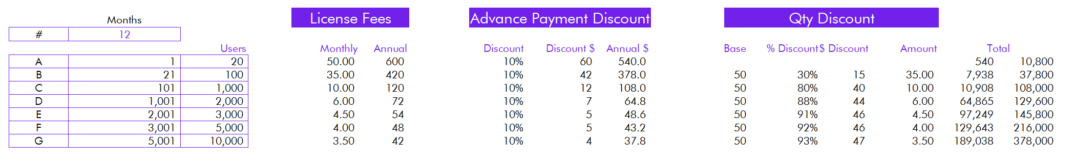
Appendix B – Skill.me Service Plan Model

